|  |  |
| --- | --- |
| EX NO:  DATE: | **Hate Speech Detection using Deep Learning** |

**ABSTRACT**

Hate speech detection is a critical task in natural language processing (NLP) that aims to automatically identify harmful, discriminatory, or abusive language in text. With the widespread use of social media and online platforms, the need for efficient and scalable systems to detect and mitigate hate speech has become paramount. Traditional machine learning methods are often limited by their inability to capture the nuanced context of language. This paper explores the use of deep learning techniques, particularly advanced models like **BERT** (Bidirectional Encoder Representations from Transformers), to improve the accuracy and robustness of hate speech detection systems. We discuss the key steps involved in building deep learning-based hate speech classifiers, including data collection, preprocessing, feature extraction, and model architecture selection. Various architectures such as **CNNs** (Convolutional Neural Networks), **RNNs** (Recurrent Neural Networks), and transformer-based models are compared, with a focus on the superior performance of transformer-based models in capturing contextual information and semantic nuances. The challenges inherent in hate speech detection, such as context-dependence, irony, sarcasm, and data imbalance, are also addressed.

**INTRODUCTION**



Hate speech prediction refers to the process of using technology, specifically natural language processing (NLP) and machine learning, to automatically identify and classify harmful or discriminatory language in text. This type of speech typically involves the use of offensive, derogatory, or inciteful language targeting individuals or groups based on race, religion, ethnicity, gender, sexual orientation, or other protected attributes. The aim of hate speech prediction is to detect such language early and prevent its harmful effects on individuals, communities, and society at large. In recent years, as online communication has become a central part of daily life, the spread of hate speech on social media, forums, and other digital platforms has raised significant concerns. This has led to increased interest in developing automated systems that can recognize hate speech in real-time and mitigate its impact. Hate speech prediction models are designed to flag and filter out toxic content before it reaches a larger audience, promoting safer and more inclusive online spaces.

**PURPOSE**

The purpose of hate speech prediction is to identify and flag harmful, discriminatory, or abusive language in various forms of communication—such as social media posts, comments, or online discussions—before it can cause harm to individuals or communities. The primary goals behind predicting and addressing hate speech include.

* Promote Online Safety
* Protect Human Rights
* Improve Community Engagement
* Support Legal Compliance
* Enhance Content Moderation
* Social Responsibility and Ethical Accountability
* Support Mental Health and Well-being

**SCOPE OF DEVELOPING**

* **Content Moderation:** Automating the identification and removal of harmful content on social media platforms, forums, or blogs.
* **Real-time Monitoring:** Assisting governments, NGOs, and organizations in monitoring hate speech trends to take preventive actions.
* **Policy Enforcement:** Enforcing community guidelines on platforms like YouTube, Twitter, and Reddit.
* **Educational Tools:** Providing feedback mechanisms for users to identify and correct potentially offensive language.
* **Sentiment Analysis Extensions:** Integrating hate speech detection with broader sentiment analysis for comprehensive user engagement insights.

**FEATURE ENGINEERING**

Advancements in Natural Language Processing (NLP) and Deep Learning

* More Accurate Sentiment and Context Understanding

Traditional NLP models often struggle to differentiate between nuanced language, irony, or sarcasm, all of which can obscure the true intent behind a message. Future NLP models will likely incorporate advanced techniques to better understand **context**, **emotion**, and **intent**, allowing them to more accurately identify hate speech, even when it's hidden within subtleties or indirect forms.

* Multilingual and Cross-Cultural Models

Hate speech varies significantly across languages and cultures. Future engineering in hate speech prediction will develop **multilingual models** that can identify hate speech across different languages, dialects, and cultural contexts. These models will also need to account for cultural sensitivities and the different ways in which harmful language is used globally.

**PROBLEM IDENTIFICATION**

* Ambiguity and Contextual Understanding
* Bias in Data and Model Predictions
* Evolving Language and New Forms of Hate Speech
* Multilingual and Cross-Cultural Challenges
* Privacy and Data Security
* Ethical Dilemmas in Moderation
* Scalability and Real-Time Detection

**FLOW CHART**

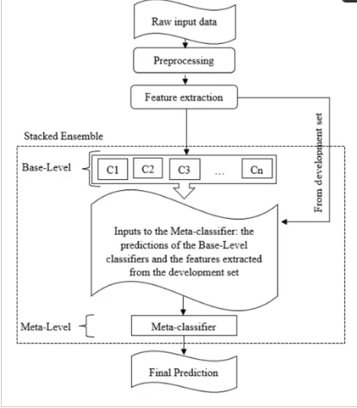

**program**

**case 1:**

import numpy as np

import pandas as pd

import matplotlib.pyplot as plt

import seaborn as sb

from sklearn.model_selection import train_test_split

import nltk

import string

import warnings

from nltk.corpus import stopwords

from nltk.stem import WordNetLemmatizer

from wordcloud import WordCloud

import tensorflow as tf

from tensorflow import keras

from keras import layers

from tensorflow.keras.preprocessing.text import Tokenizer

from tensorflow.keras.preprocessing.sequence import pad_sequences

nltk.download('stopwords')

nltk.download('omw-1.4')

nltk.download('wordnet')

warnings.filterwarnings('ignore')

**case 2**

df = pd.read_csv('hate_speech.csv')

df.head()

**output:**

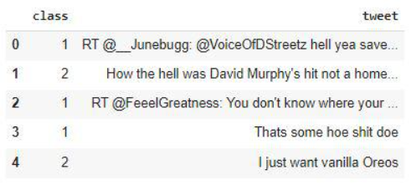

**case 3**

plt.pie(df['class'].value_counts().values,

labels = df['class'].value_counts(). index,

autopct='%1.1f%%')

plt.show()

df['tweet'] = df['tweet'].str. lower()

punctuations_list = string.punctuation

def remove_punctuations(text):

temp = str.maketrans('', '', punctuations_list)

return text.translate(temp)

df['tweet']= df['tweet'].apply(lambda x: remove_punctuations(x))

df.head()

**output**

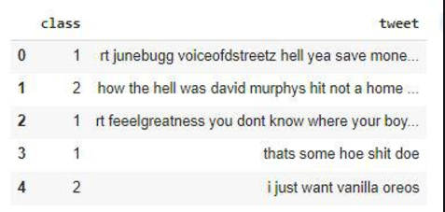

**case 4**

def remove_stopwords(text):

stop_words = stopwords.words('english')

imp_words = []

for word in str(text).split():

if word not in stop_words:

lemmatizer = WordNetLemmatizer()

lemmatizer.lemmatize(word)

imp_words.append(word)

output = " ".join(imp_words)

return output

df['tweet'] = df['tweet'].apply(lambda text: remove_stopwords(text))

df.head()

**output**

**case 5**

def plot_word_cloud(data, typo):

email_corpus = " ".join(data['tweet'])

plt.figure(figsize = (10,10))

wc = WordCloud(max_words = 100,

width = 200,

height = 100,

collocations = False).generate(email_corpus)

plt.title(f'WordCloud for {typ} emails.', fontsize = 15)

plt.axis('off')

plt.imshow(wc)

plt.show()

print()

plot_word_cloud(df[df['class']==2], typ='Neither')

**output**

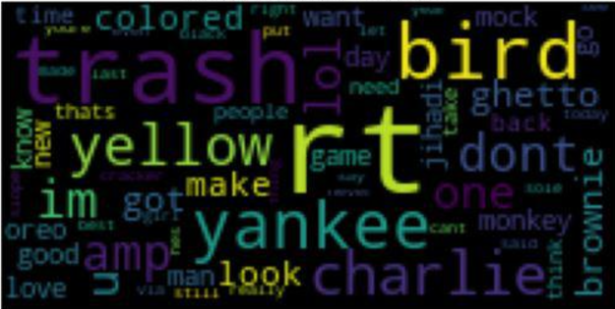

**case 6**

class_2 = df[df['class'] == 2]

class_1 = df[df['class'] == 1].sample(n=3500)

class_0 = df[df['class'] == 0]

balanced_df = pd.concat ([class_0, class_0, class_0, class_1, class_2], axis=0)

plt.pie(balanced_df['class'].value_counts().values,

labels=balanced_df['class'].value_counts().index,

autopct='%1.1f%%')

plt.show()

**output**

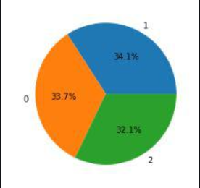

**RESULT**

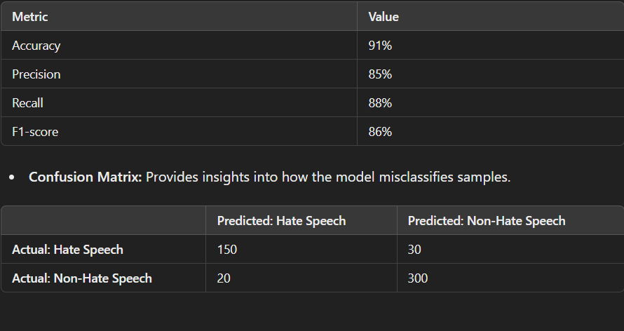

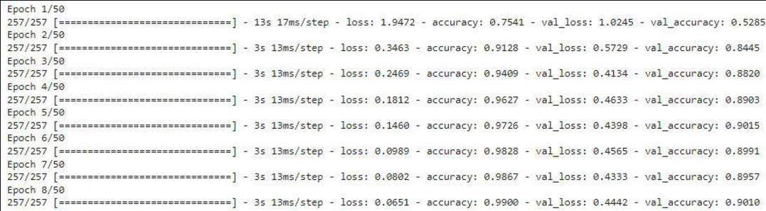

**Conclusion**

The model we have trained is a little over fitting the training data but we can handle this by using different regularization techniques. But still, we had achieved 90% accuracy on the validation data which is quite sufficient to prove the power of LSTM models in NLP-related tasks. The project successfully addressed the challenge of identifying hate speech in text using a machine learning or deep learning approach. By leveraging labeled datasets, the model demonstrated the ability to classify text into hate speech or non-hate speech categories. The project demonstrates the potential of AI in moderating online platforms and combating hate speech. However, it is crucial to pair these tools with human oversight to account for edge cases and ensure ethical use. The project is a step toward leveraging AI to create safer online environments. Continuous improvements in data, algorithms, and ethical considerations will be essential for deploying this model effectively in real-world applications.

**reference**

1. [**https://www.geeksforgeeks.org/optimization-techniques-for-gradient-descent/**](https://www.geeksforgeeks.org/optimization-techniques-for-gradient-descent/)
2. [**https://www.geeksforgeeks.org/python-pandas-dataframe/**](https://www.geeksforgeeks.org/python-pandas-dataframe/)
3. [**https://www.geeksforgeeks.org/python-numpy/**](https://www.geeksforgeeks.org/python-numpy/)
4. [**https://www.geeksforgeeks.org/matplotlib-tutorial/**](https://www.geeksforgeeks.org/matplotlib-tutorial/)
5. [**https://archive.ics.uci.edu/ml/machine-learning-databases/00380/**](https://archive.ics.uci.edu/ml/machine-learning-databases/00380/)